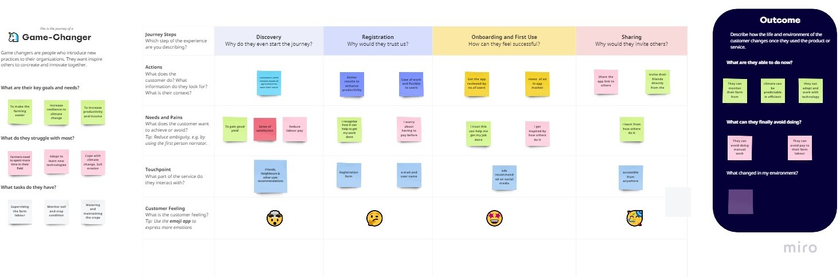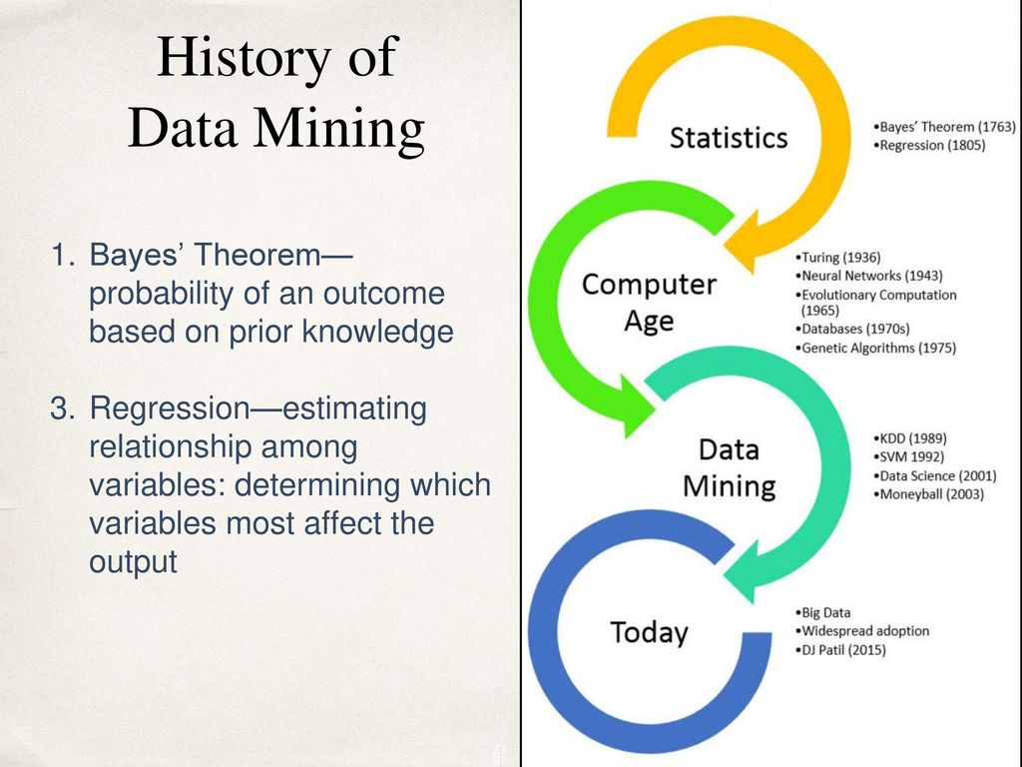

* **They can avoid doing manual work**
* **Making well-informed decisions could save costs and enhances a farmer’s profitability and income**

What can they finally avoid doing

prediction

Identification

Classification

optimization

**Data mining in agriculture** is a recent research topic, consisting of the application of [data mining](https://en.wikipedia.org/wiki/Data_mining) techniques to [agriculture](https://en.wikipedia.org/wiki/Agriculture). Recent technologies are able to provide extensive information on agricultural-related activities, which can then be analyzed in order to find relevant information.

Farmers use yield estimates to anticipate equipment, fuel and labor needs, ensure they have enough storage available, plan livestock feed supplies, and make early marketing decisions.

 

ROLE OF DATA MINING IN AGRICULTURE